Name: ___________________________________________

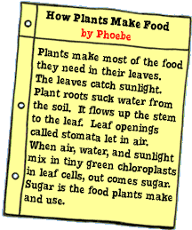
Date: ____________________________________________

